Select HERO app in:  Or type: app.linc-ed.com/login into web browser | Select HERO app in:  Or type: app.linc-ed.com/login into web browser | Select HERO app in:  Or type: app.linc-ed.com/login into web browser | Select HERO app in:  Or type: app.linc-ed.com/login into web browser
Click “New User”  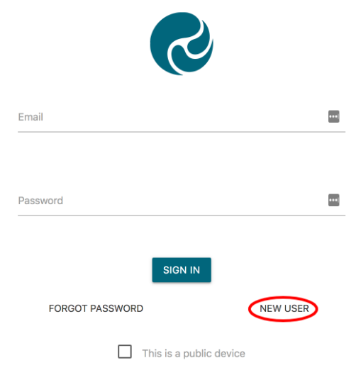 | Click “New User” | Click “New User” | Click “New User”
Enter the email address you have provided the school and click REQUEST PASSWORD LINK  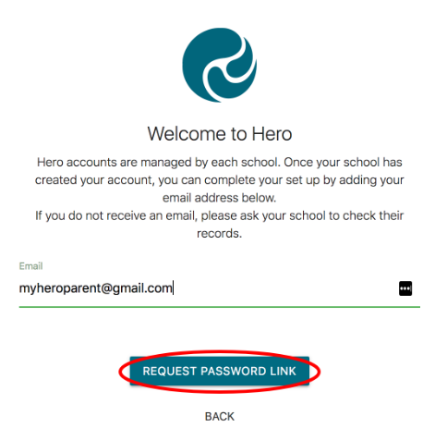 | Enter the email address you have provided the school and click REQUEST PASSWORD LINK | Enter the email address you have provided the school and click REQUEST PASSWORD LINK | Enter the email address you have provided the school and click REQUEST PASSWORD LINK
Check your email | Check your email | Check your email | Check your email
Follow the link: This will take you to a secure page to reset your password | Follow the link: This will take you to a secure page to reset your password | Follow the link: This will take you to a secure page to reset your password | Follow the link: This will take you to a secure page to reset your password
If you have any issues please let the school know | If you have any issues please let the school know | If you have any issues please let the school know | If you have any issues please let the school know

You can access all your child’s learning information by logging into your app or logging in through the website.  Use your registered email to access learning at any point during the year.  Your child’s teacher will add learning posts throughout the year. You will receive an email alert when this happens.  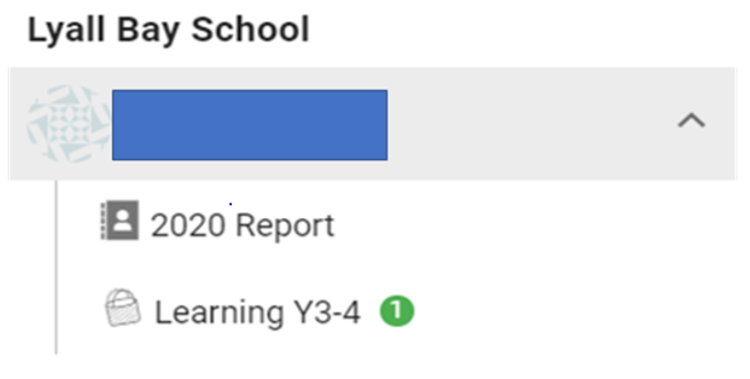  Along with learning posts, you will also receive alerts regarding medical treatment received by your child. | You can access all your child’s learning information by logging into your app or logging in through the website.  Use your registered email to access learning at any point during the year.  Your child’s teacher will add learning posts throughout the year. You will receive an email alert when this happens.  Along with learning posts, you will also receive alerts regarding medical treatment received by your child. | You can access all your child’s learning information by logging into your app or logging in through the website.  Use your registered email to access learning at any point during the year.  Your child’s teacher will add learning posts throughout the year. You will receive an email alert when this happens.  Along with learning posts, you will also receive alerts regarding medical treatment received by your child. | You can access all your child’s learning information by logging into your app or logging in through the website.  Use your registered email to access learning at any point during the year.  Your child’s teacher will add learning posts throughout the year. You will receive an email alert when this happens.  Along with learning posts, you will also receive alerts regarding medical treatment received by your child.
Lyall Bay School  Building the Best Learners Waihangatia ngā Ākonga Tino Pai | Lyall Bay School  Building the Best Learners Waihangatia ngā Ākonga Tino Pai | Lyall Bay School  Building the Best Learners Waihangatia ngā Ākonga Tino Pai | Lyall Bay School  Building the Best Learners Waihangatia ngā Ākonga Tino Pai

